HibsBlues Coffee – Sales Analysis 🐻

Dataset: Coffee Shop Sales (Kaggle) · Mar 2024 – Mar 2025
Coffee Sales Dataset

1. Dataset Information
The dataset contains transactional data from a coffee shop, including product details, pricing, timestamps, and customer purchase behavior.
Key Columns:

- Date: Transaction date
- Time: Exact purchase time
- hour_of_day: Hour extracted from time
- coffee_name: Product name
- money: Transaction amount
- cash_type: Payment method (card/cash)
- Time_of_Day: Morning / Afternoon / Night
- Weekday: Day of week
- Month_name: Month of purchase
- Weekdaysort / Monthsort: Ordering features

Dataset Overview
Dataset: Coffee Shop Sales (Kaggle)
Time Period: March 2024 to March 2025
Total Records: 3,547 transactions
Total Columns: 11
Products: 8 coffee types

DATASET CLEANING STEPS:

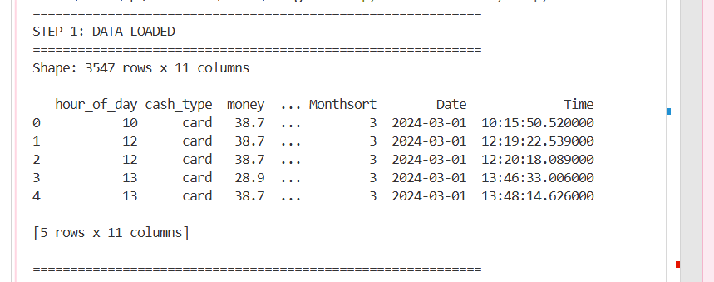

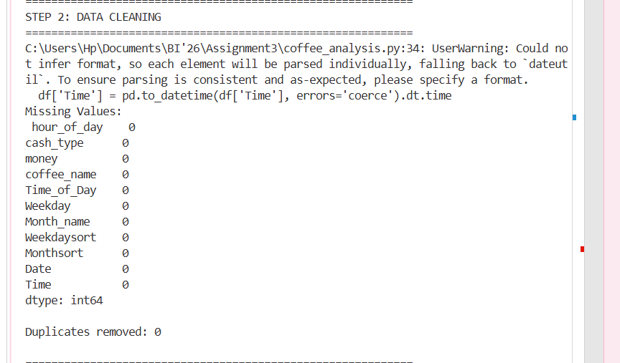

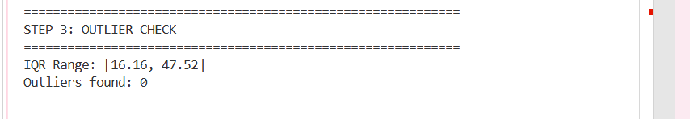

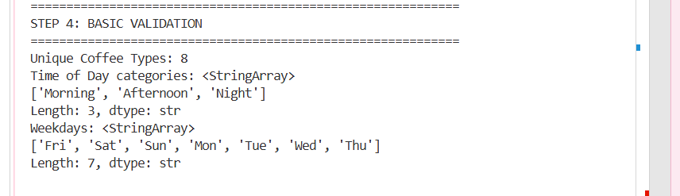

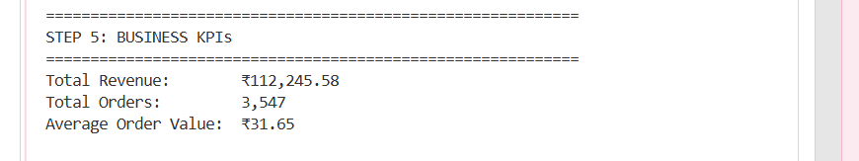

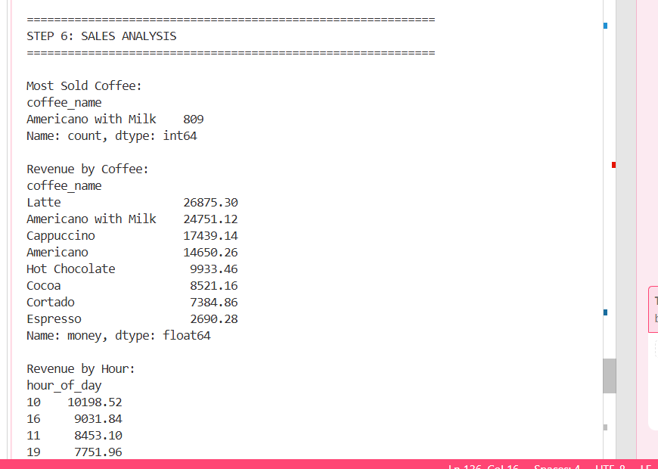

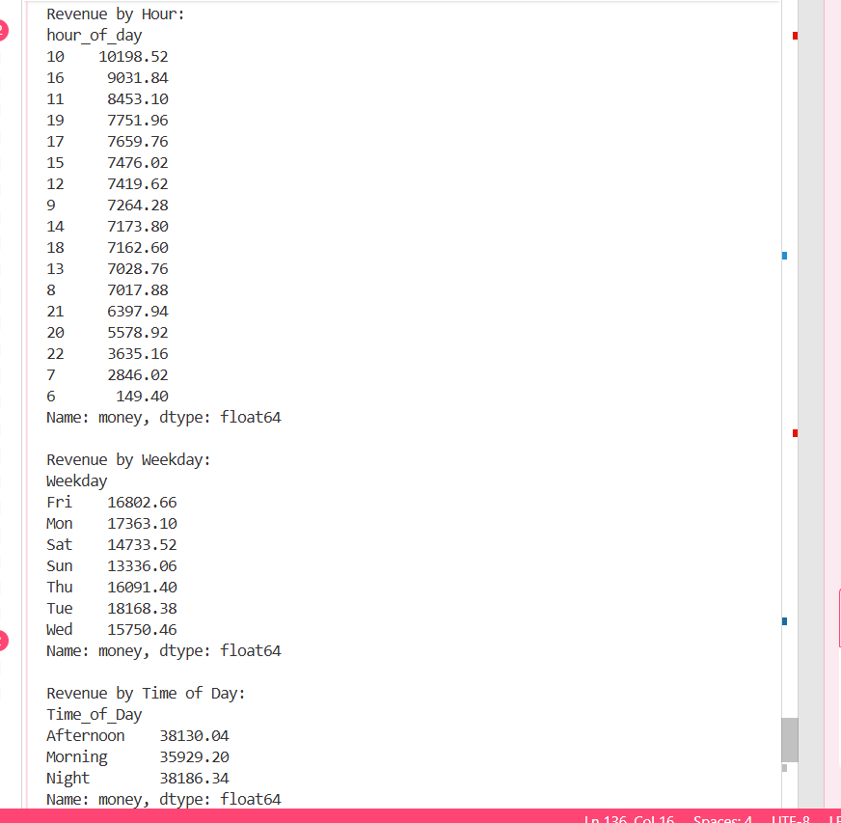

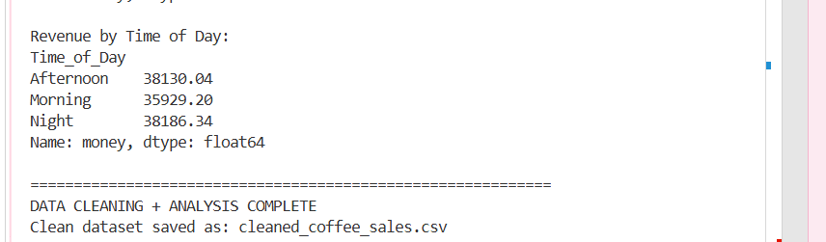

The dataset was clean, structured, and ready for analysis with minimal preprocessing required.

Fact & Dimension Model

Although the dataset contains only one numerical attribute (money), additional business measures such as Transaction Count and Average Order Value (AOV) were derived to support analytical insights.

Fact Table: Sales Transactions
Measures:
- Revenue (money)
- Transaction Count
- Average Order Value
Each row represents a single transaction.

Dimensions
Product (coffee_name)
Time (Date, hour_of_day, Time_of_Day)
Weekday
Month
Payment Method (cash_type)

2. Problem Statement

A specialty coffee shop operating between 2024–2025 aims to improve operational efficiency and profitability by understanding customer purchasing behavior.
Despite steady daily transactions, management lacks clarity on:
- Peak sales hours
- High performing products
- Revenue fluctuations across time
This analysis uses 3,547 transactions to identify sales patterns and provide actionable business recommendations.

Research Questions
- When are peak sales hours and days?
- Which coffee types generate the highest revenue?
- Are there seasonal fluctuations in sales performance?

3. Power BI Dashboard Overview
Page 1: Overview Dashboard

My First Page includes:
- Total Revenue KPI : This shows total money earned from all coffee sales.
- Total Transactions KPI : how many total coffees were sold.
- Average Order Value KPI : On average, each customer spends this much money

- Product Count KPI: This is the coffee people buy the most.
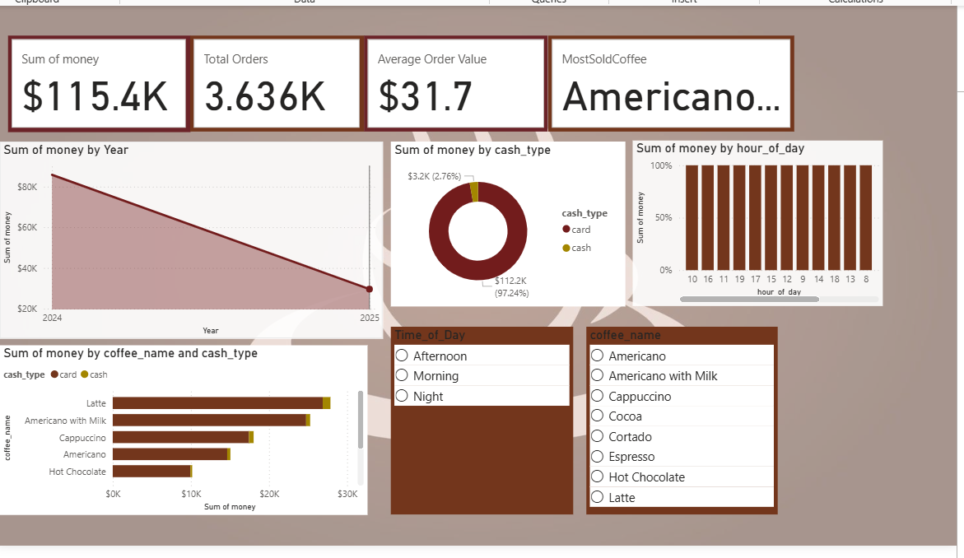

Key Visuals:
- Revenue trend overtime (Area Chart): Sales go up and down over time. Some days have more customers, some less.
- Coffee wise revenue (Stacked Bar Chart): Different coffees earn different money. Cards are used more than cash.
- Payment method distribution (Donut Chart): Most people pay using card instead of cash.

Page 2: Time Based Analysis
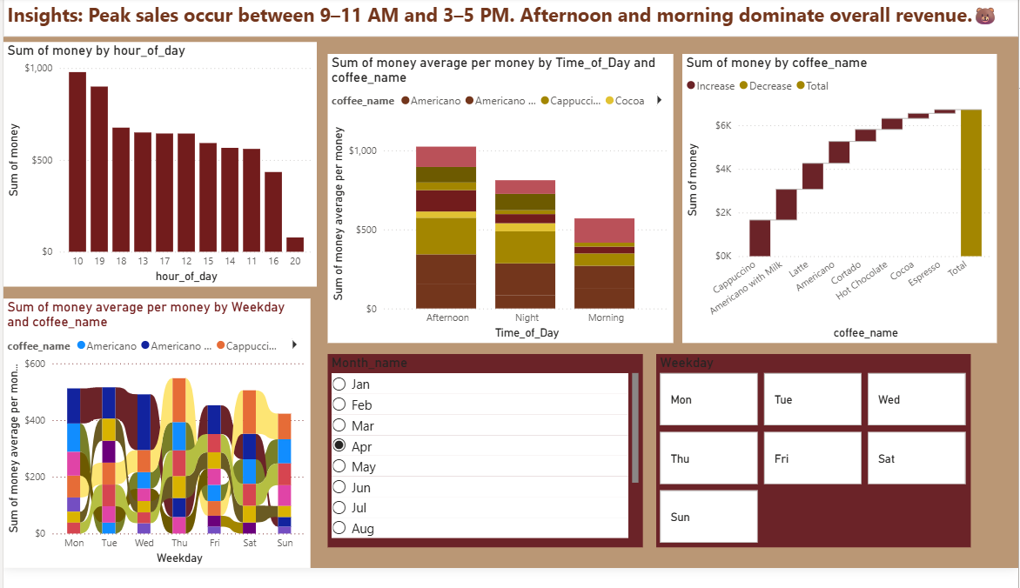

Includes:
- Hour wise revenue analysis
- Weekday performance
- Time of day breakdown
Key Visuals:
- Clustered Column Chart (hour_of_day) : More sales happen in some hours. These are busy hours
- Ribbon Chart (weekday vs coffee type) : Coffee popularity changes on different days.
- Stacked Column (Time_of_Day) : Afternoon and morning have more sales than night.
- Waterfall Chart (revenue contribution) : Each coffee adds some part to total money and Some days are busier than others. Weekdays usually have more sales.

Page 3: Product Analysis
Includes:
- Coffee popularity
- Revenue contribution by product
- Payment behavior
Key Visuals:
- Clustered Bar Chart (coffee_name vs sales) : Some coffees are sold more than others.
- Donut Chart (product share) : Few coffees make most of the sales.
- Sunburst Chart (product + time + payment breakdown) : top coffees bring most money. Others bring less. Customers choose different coffees at different times.This shows hierarchy of product, time, and payment.
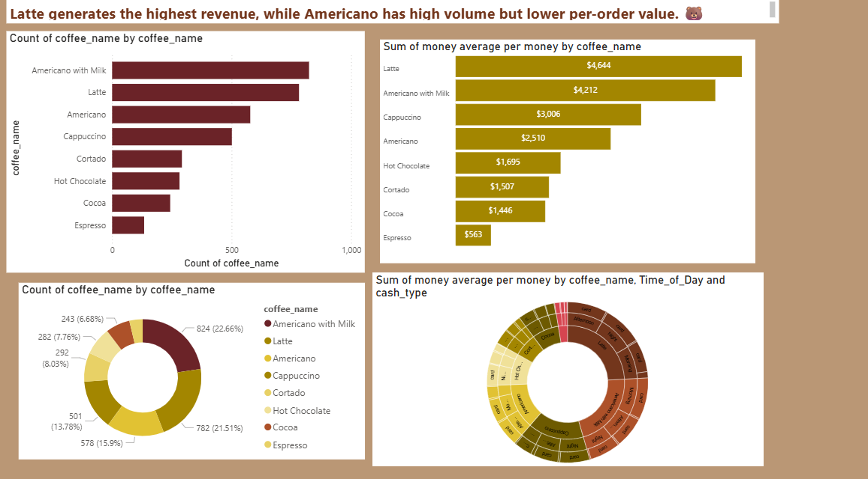
Page 5 & 6: Advanced Insights
Includes:
- Decomposition Tree (revenue breakdown): This breaks total money into parts to see what affects sales.
- Scatter Plot (price vs time behavior): Higher spending happens during busy hours.
- Weekday product analysis: Some coffees are more popular on certain days.
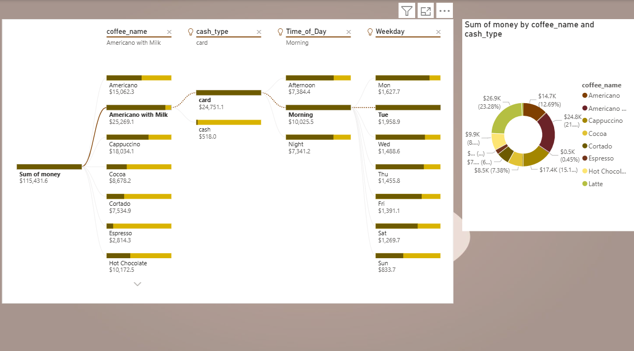

This chart breaks total sales into smaller parts
• It shows which factors increase or decrease sales
• We can see which coffee, time, or day gives more revenue
• It helps find the main reason behind high sales
• It makes complex data easy to understand step by step

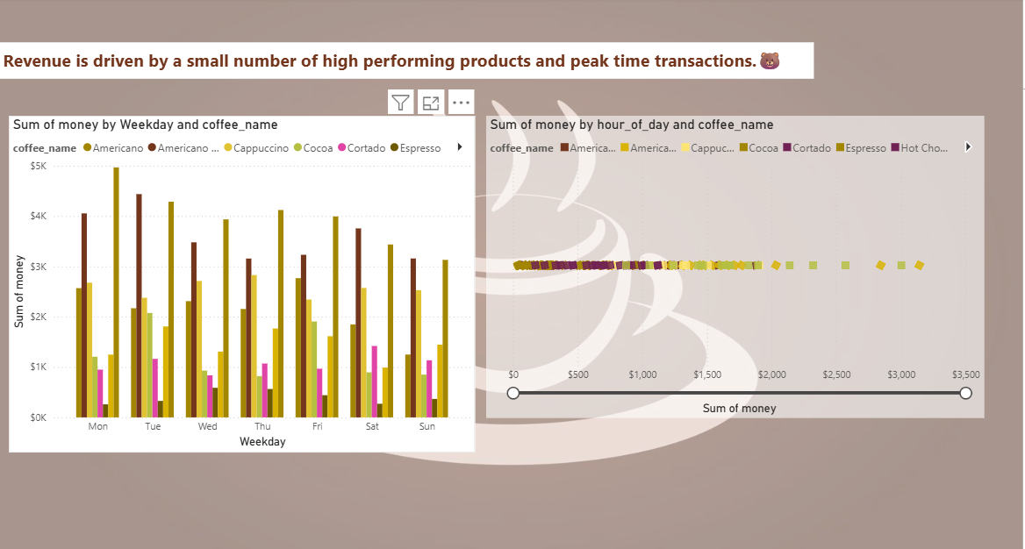

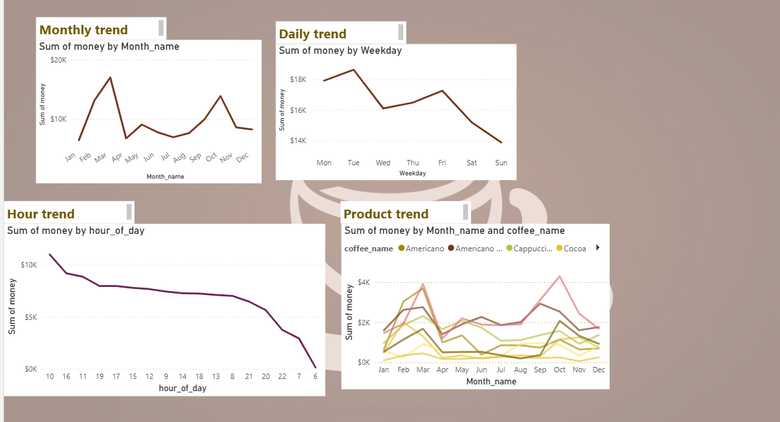

• Sales change over time and do not stay constant
• Some months and days have higher sales while others are lower
• There are clear peak hours where most customers buy coffee
• Morning and afternoon usually have more sales than night
• Weekdays often perform better than weekends
• Different coffee products show different trends over time
• Some products stay stable while others increase or decrease
• These patterns show customer behavior is not the same every time
• Overall, sales follow a trend with ups and downs, not a fixed pattern
• This helps the business understand when demand is high and when it is low

4) FINAL INSIGHTS
- 10 AM is peak revenue hour
- Latte is top-selling product
- Afternoon is strongest time segment
- Tuesday is best weekday
- Espresso underperforms
- Weekdays outperform weekends
- Card payments dominate

5) RECOMMENDATIONS

•Increase staff during 9 to 11 AM and 3 to 5 PM peak hours to handle high customer demand and reduce waiting time
• Promote low performing products like Espresso through discounts or combo deals to improve their sales
• Run targeted promotions during low performing months to boost customer traffic and stabilize revenue
• Introduce weekend offers or loyalty programs to increase sales on slower days
• Bundle low selling drinks with popular items like Latte to improve overall sales mix and increase average order value

